UNIVERSITI MALAYSIA SARAWAK
Faculty of Computer Science and Information Technology
TMA3084 Software Engineering Laboratory | Semester 1, 2026/2027
MEETING MINUTES

A. Meeting Details
Group No. / Name | Group 21 – ByteChew | Lab Group / Demonstrator | Group 2 – Mr Raynold anak Kabai
Project Title | Tracking App
Meeting No. | 01 | Project Week / Milestone | Week 3  ☑ M1 ☐ M2 ☐ M3 ☐ M4
Date | 10/10/2026 | Time (start – end) | 14:30 – 14:51
Meeting Type | ☐ Team meeting ☑ Client meeting ☐ Lecturer / demonstrator consultation
Mode / Location | ☐ Physical ☑ Online Google Meet: https://meet.google.com/ses-brgh-nce
Chairperson | Muhammad Afiq bin Sakub | Minute Taker | Syafik bin Sali
Meeting Objective | This meeting must confirm the problem statement, target users and core features of the campus events app with the client, and capture any client feedback that affects the requirements or UI design.

B. Attendance
No. | Name | Matric No. / Organisation | TSPi Role / Position | Present / Absent | Signature
1 | Muhammad Afiq bin Sakub | 102719 | Team Leader, Planning Manager | ☑ P ☐ A | 
2 | Ahmad Danish bin Alin | 102384 | Quality/Process Manager | ☑ P ☐ A | 
3 | Adenillo Sheldy anak Stephen | 102372 | Support Manager | ☑ P ☐ A | 
4 | Shelsy anak Nicholas Felix | 102958 | Development Manager | ☑ P ☐ A | 
5 | Syafik bin Sali | 102978 | Client Liaison/ Developer | ☑ P ☐ A | 
6 | Lambert | Skybylamby | Client | ☑ P ☐ A
Absent with reason |  | None

C. Review of Previous Action Items First meeting: write “Not applicable”
No. | Action item from previous meeting | Owner | Status | Remarks
1 | Not applicable |  | ☐ Done  ☐ In progress  ☐ Not started
2 |  |  | ☐ Done  ☐ In progress  ☐ Not started
3 |  |  | ☐ Done  ☐ In progress  ☐ Not started

D. Agenda and Discussion Copy an agenda block for each additional item
Agenda Item #1: Identification of Problem Statement
Discussion | The team discussed with the client on the challenges event organisers currently face when promoting events on campus. Event details are shared mainly through social media, so they often fail to reach the intended audience, which leads to low engagement. As a result, students and other potential attendees lack clear and centralised information about the upcoming events. Client noted that organisers have no systematic way to find out how many people plan to attend, which makes it hard to estimate seats, food and materials beforehand.
Decision | The team agreed to focus the solution on bridging the information gap between organisers and attendees. The proposed solution is a centralised mobile app that improves event reach and engagement and gives organisers a live count of confirmed attendees.
Reference

Agenda Item #2: Target Audience
Discussion | The team defined the user roles and target audience for the app. Students will use it to discover campus events, view event details on the map, receive reminders and confirm their attendance. The general public will be able to browse events that are open to the public and find their locations on the map. Event organisers, who are part of the student committee members or staff are able to create and manage events and monitor the number of confirmed attendees. Finally, a university staff member or a designated team member will act as the system admin to approve or reject submitted events and manage organiser accounts.
Decision | The app will have two main user perspectives. Attendees can discover events, view the map, confirm their attendance and receive reminders, while organisers can create events and see how many people have confirmed. A simple admin interface will also be included so that admins can approve events and manage content.
Reference

Agenda Item #3: Proposed Core Features
Discussion | The team evaluated 3 features for the app. The first is a push notification reminder, which is sent 1 week before an event that a user has booked to help them remember to attend. The second is an interactive campus map with a bubble at each event location, and when users taps a bubble, they can see the event name, date, time and a short description. The third is a confirm attendance button which lets users confirm their attendance with one tap and cancel it if their plans change, while organisers can see a live count of how many students have confirmed.
Decision | The team agreed to include all 3 features in the project scope which is the 1-week push notification reminder, the interactive campus map with event bubbles, and the confirm attendance button with a live attendee count. Multiple reminder times, QR check-in and analytics dashboards were deferred as out of scope.
Reference

E. Client Feedback and Requirement Changes Client meetings only; otherwise “Not applicable”
No. | Feedback / change requested by client | Affected requirement (FR‑xx) | Agreed response
1 | Client requested blue as the main colour and black as the secondary colour for the colour palette of the application. | No existing FR affected | The team agreed to use blue as the primary colour and black as the secondary colour in the UI design.  ☐ Change request (CCR) raised
2 | Client highly discourages the AI ChatBot feature for the application. | FR-AI-01 | The team agreed not to include an AI chatbot. The AI feature will stay limited to interest-based filtering and sorting of events.  ☐ Change request (CCR) raised

F. Action Items
No. | Action item | Owner | Due date | GitHub Issue # / TSPi task
1 | Update the proposal’s problem statement to focus on the information gap between organisers and attendees | Syafik | 15/10
2 | Finalise the user roles (Student, General Public, Organiser, Admin) in the target users table | Danish | 15/10
3 | Update the scope table. Multiple reminder times, QR check-in and analytics dashboards out of scope | Shelsy | 15/10
4 | Remove the AI chatbot from the requirements. Revise FR-AI-01 to interest-based filtering and sorting of events | Adenillo | 15/10
5 | Set up GitHub repository | Afiq | 15/10

G. Adjournment and Next Meeting
Meeting adjourned at | 14:51 | Next meeting (date / time) | 14/10/2026, 21:00
Next mode / location | Google Meet | Proposed agenda | Proposal Quality Check

H. Sign-off
Prepared by  Minute Taker  Signature: ______________________  Name: Syafik bin Sali  Date: 11/10/2026 | Verified by  Team Leader  Signature: ______________________  Name: Muhammad Afiq bin Sakub  Date: 11/10/2026 | Acknowledged by  Client  Signature: ______________________  Name: Lambert Gan anak Thomas  Date: 11/10/2026

Attachment

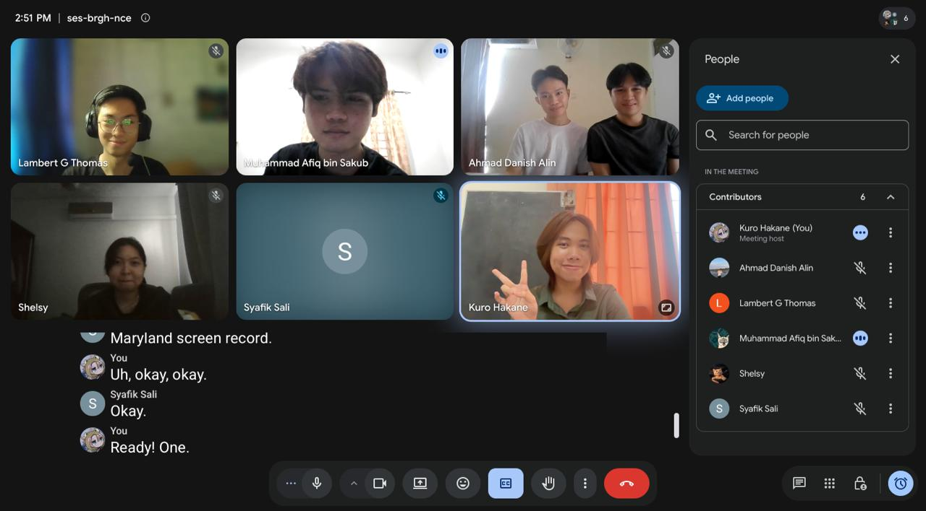

▸ Attach evidence for client meetings (attendance photo or online-meeting screenshot). If an AI tool was used to transcribe or summarise this meeting, record it in LOGAI and check the minutes for accuracy before signing.

